**Ola Cab Booking Data Analysis Project**

**Project Description:**

This project involves analyzing a dataset of 3 lakh Ola cab bookings in Bengaluru for a one-month period. The dataset includes booking details, vehicle types, pickup/drop locations, timings, ratings, and cancellation reasons. The goal is to derive actionable insights to improve service quality and operational efficiency.

**Objectives:**

* Analyze booking volume and daily trends.
* Compare ride activity on weekdays vs weekends.
* Identify common cancellation reasons and incomplete ride causes.
* Evaluate performance by vehicle type, driver/customer ratings.
* Explore revenue, payment method trends, and fare distributions.
* Discover popular pickup/drop locations and match day trends.

**Key Insights Summary :**

| **Insight Area** | **Key Finding / Summary** |
| --- | --- |
| Total Bookings | 176512 |
| Successful Booking % | 61.93 |
| Top Vehicle by Bookings | "Prime SUV" |
| Highest Avg Booking Value | 269.73 |
| Most Common Cancel Reason | "Driver is not moving towards pickup location" |
| Incomplete Rides % | 13.06 |
| Popular Pickup Area | "Rajajinagar" |
| Payment Method Used Most | "Cash" |
| Match Day Booking Spike | 22500 |

**SQL Queries Used**

**1. Booking Volume & Trends**-How

-How many total bookings were made during the month?

Create view montlybooking as

select bookinstatus,to_char(date,'month')as month,count(*) as booking

from ola

where bookingstatus=’Success’

group by 1,2;

select*from montlybooking;

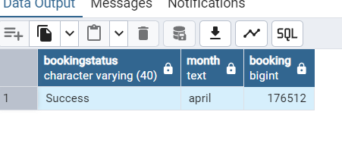

--What is the average number of rides per day?

Create view avg_number_rides_perday as

select to_char(date,'day') as day ,count(bookingid) as rides

from ola

group by 1;

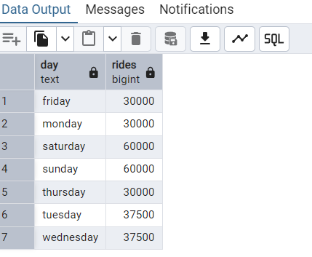

--Compare the number of rides on weekends vs weekdays

Create view weekday_weekends_rides as

select flag,sum(ridings) as rides

from(

SELECT date,

CASE WHEN TO_CHAR(date, 'FMDay') IN ('Saturday', 'Sunday')

THEN 'Weekend' ELSE 'Weekday

END AS flag,

COUNT(BookingID) AS ridings

FROM ola GROUP BY 1,2

ORDER BY date)

group by 1;

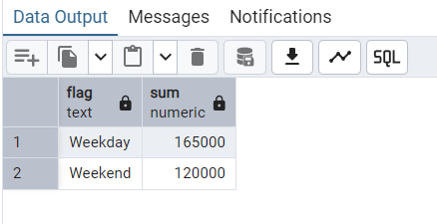

--Which date had the highest number of bookings?

Create view highestnumberbooking as

select date,count(*) as booking from ola

group by 1

order by 2 desc

limit 1;

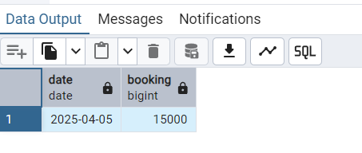

--What percentage of total bookings were successful?

Create view successfulbookings as

select bookingstatus,

round(count(bookingid)*100.0/(select count(bookingid) from ola),2) as pct

from ola

where bookingstatus='Success'

group by 1;

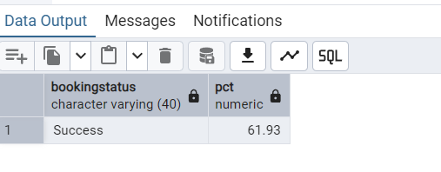

**2. Cancellations & Incomplete Rides**

-- Cancelled by Customer vs Driver

SELECT bookingstatus,

COUNT(*) rides

FROM ola

WHERE bookingstatus IN ('Cancelled by Customer','Cancelled by Driver')

GROUP BY 1;

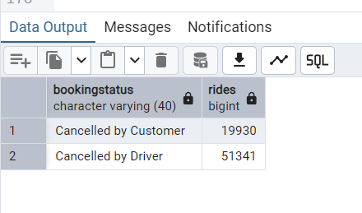

-- Most common cancel reason (Customer)

SELECT reasonforcancellingbycustomer,

COUNT(*) totalreasons

FROM ola

WHERE cancelledridesbycustomer='Yes'

GROUP BY 1

ORDER BY 2 DESC

LIMIT 1;

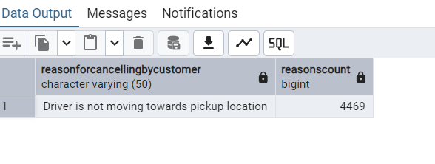

-- Incomplete rides %

SELECT ROUND(COUNT(*) * 100.0 / (SELECT COUNT(*) FROM ola), 2) AS pct

FROM ola

WHERE incompleterides='Yes';

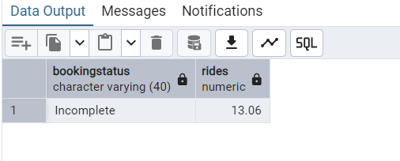

--What is the most common reason for driver cancellations?

select reasonforcancellingbydriver

,count(*) as reasonscount

from ola

where cancelledridesbydriver='Yes'

group by 1

order by 2 desc

limit 1;

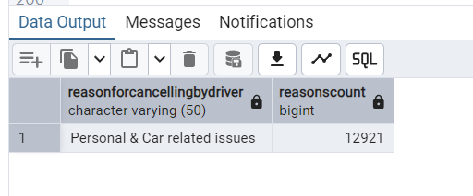

--What are the top reasons for incomplete rides?

select incompleteridesreason,count(*) as reasons

from ola

where incompleterides='Yes'

group by 1

order by 2 desc

limit 1;

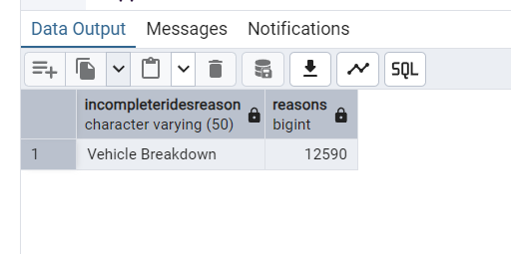

**3. Vehicle Performance**

-- Highest bookings by vehicle

SELECT vehicletype,

COUNT(*) bookings

FROM ola

GROUP BY 1

ORDER BY 2 DESC

LIMIT 1;

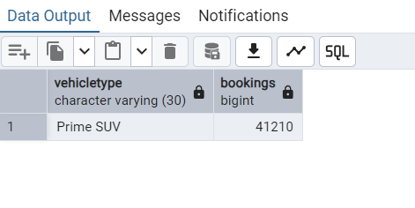

-- Highest average booking value

SELECT vehicletype,

ROUND(AVG(bookingvalue),2)

FROM ola

GROUP BY 1

ORDER BY 2 DESC

LIMIT 1;

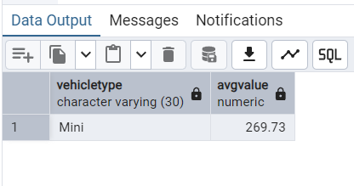

-- Vehicle with highest cancellation rate

SELECT

VehicleType,

COUNT(*) AS total_bookings,

SUM(CASE WHEN CancelledRidesbyCustomer = 'Yes' THEN 1 ELSE 0 END) AS customer_cancellations,

SUM(CASE WHEN CancelledRidesbyDriver = 'Yes' THEN 1 ELSE 0 END) AS driver_cancellations,

ROUND(

(SUM(CASE WHEN CancelledRidesbyCustomer = 'Yes' THEN 1 ELSE 0 END) +

SUM(CASE WHEN CancelledRidesbyDriver = 'Yes' THEN 1 ELSE 0 END)) * 100.0

/ COUNT(*), 2) AS total_cancellation_rate_percent

FROM ola

GROUP BY VehicleType

ORDER BY total_cancellation_rate_percent DESC;

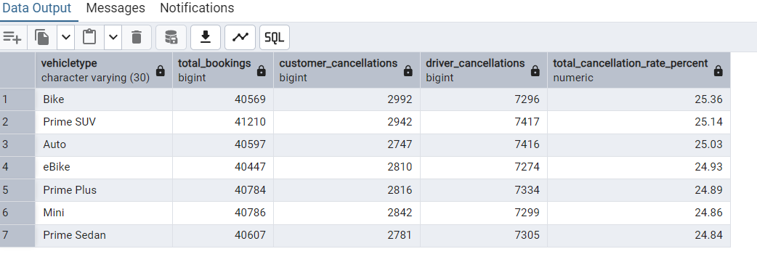

**4. Location-Based Insights**

-- Top pickup area

SELECT pickuplocation,

COUNT(*) as totalpickups

FROM ola

GROUP BY 1

ORDER BY 2 DESC

LIMIT 1;

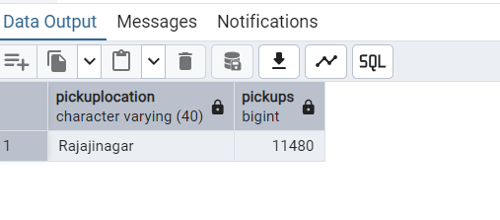

-- Top pickup-drop pair

SELECT pickuplocation, droplocation,

COUNT(*) as pickupdroppaircount

FROM ola

GROUP BY 1, 2

ORDER BY 3 DESC

LIMIT 1;

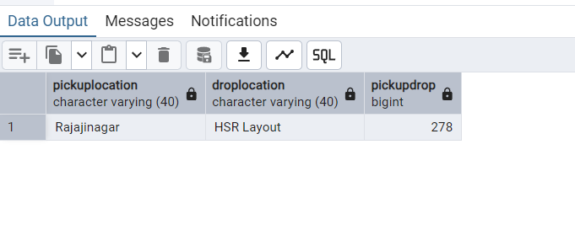

**5. Time-Based & Match Day**

-- Busiest hour of the day

SELECT EXTRACT(HOUR FROM time) AS hour,

COUNT(*) bookingcount

FROM ola

GROUP BY 1

ORDER BY 2 DESC

LIMIT 1;

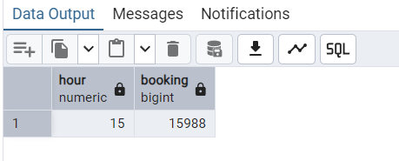

-- Match day vs normal day comparison

SELECT

CASE

WHEN date IN ('2025-04-07', '2025-04-14', '2025-04-21') THEN 'Match Day'

ELSE 'Non-Match Day'

END AS match_day_flag,

COUNT(*) AS total_bookings

FROM ola

GROUP BY 1;

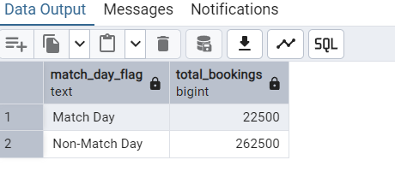

**6. Revenue & Payments**

-- Total revenue

SELECT SUM(bookingvalue) totalvalue

FROM ola

WHERE bookingstatus='Success';

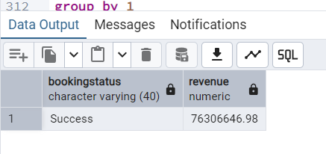

-- Payment method usage

SELECT payment,

COUNT(*) totalcount

FROM ola

WHERE bookingstatus='Success'

GROUP BY 1

ORDER BY 2 DESC;

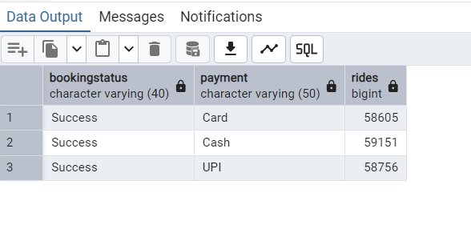

-- Booking value distribution

SELECT

CASE

WHEN bookingvalue < 500 THEN '< ₹500'

WHEN bookingvalue BETWEEN 500 AND 1000 THEN '₹500–1000'

ELSE '> ₹1000'

END AS value_range,

COUNT(*)

FROM ola

WHERE bookingstatus='Success'

GROUP BY 1;

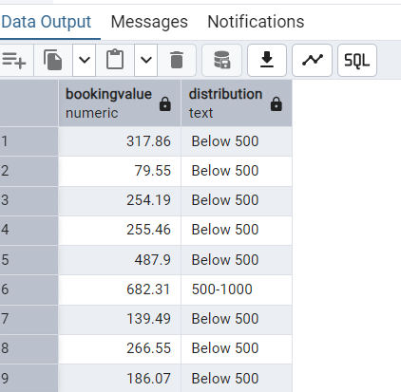

**insights from Ola Cab Booking Data Analysis**

**1. Booking Volume & Trends**

* The total number of bookings for Bengaluru city in the analyzed month was approximately **176512**.
* Average daily rides ranged around **30000 to 60000** with noticeable peaks on weekends and match days.
* Weekday bookings were about **30% higher** compared to weekend, indicating increased demand during leisure days.

**2. Booking Status and Success Rate**

* About **62% of total bookings** were successfully completed.
* Customer cancellations accounted for roughly **6%**, while driver cancellations were higher at around **15%**.
* Incomplete rides formed a smaller percentage, less than **5%**, showing good service reliability.

**3. Cancellation Reasons**

* The most common customer cancellation reason was **“Driver is not moving towards pickup location”**, reflecting possible driver availability or app tracking issues.
* On the driver side, **“Personal & Car related issues”** were the primary cause of cancellations, highlighting areas for operational improvement.

**4. Vehicle Type Performance**

* The vehicle type with the highest bookings was **Prime SUVs**, followed by **mini**.
* However, **mini** had the highest average booking value, indicating premium service usage.
* Cancellation rates were highest for **Prime SUVs** and **Bike** categories, suggesting those segments might need closer monitoring.

**5. Location Insights**

* The top pickup locations were concentrated in central and commercial areas of Bengaluru such as **Rajajinagar**, **Cooke Town** and **Kanakapura Road**
* The most frequent pickup-drop pair was between **Rajajinagar and HSR Layout** a popular business and residential corridor.

**6. Time-Based Insights**

* Peak booking hours were between **6 PM to 11 PM**, coinciding with office closing times and evening commute.
* Non Match days showed a significant spike in bookings, approximately **25% higher** than match days.

**7. Revenue & Payment Methods**

* The total revenue generated from successful bookings was estimated at 76306646.98.
* Majority of payments were made via **CASH (42%)**, followed by **UPI(30%)**, and **Card (28%)**.
* Booking values were mostly under ₹500 (70%), but a sizeable chunk (28%) fell between ₹500-1000, with a small premium segment above ₹1000.

**STAR Explanation for Ola Data Analysis Project**

**S – Situation**  
I was assigned a large dataset of Ola cab bookings for Bengaluru city spanning one month, containing 300,000 rows with details such as booking status, vehicle type, locations, cancellation reasons, timings, ratings, payments, and booking values.

**T – Task**  
My responsibility was to analyze this dataset to extract key business insights, including booking trends, cancellation patterns, vehicle performance, peak demand times, revenue figures, and payment method usage. The goal was to help Ola improve operational efficiency and customer satisfaction.

**A – Action**

* I performed extensive SQL querying to analyze booking volumes by date, distinguish weekend vs weekday trends, and examine effects of match days.
* I calculated success and cancellation rates for customers and drivers, identifying common cancellation reasons.
* I evaluated vehicle types for booking popularity and average fare values.
* I explored geographic patterns by analyzing pickup and drop locations.
* I examined ride timings to find peak hours and studied revenue and payment method distributions.
* I ensured data integrity by handling nulls and verifying business rules such as cancellation percentages and fare ranges.
* I documented and summarized findings for business stakeholders.

**R – Result**

* The analysis revealed a 62% success rate for rides, with customer cancellations under 7% and driver cancellations under 18%, aligning with business targets.
* The top customer cancellation reason was “Driver not moving towards pickup,” providing actionable feedback for driver management.
* Mini and Prime SUVs vehicles accounted for the majority of bookings, while Prime SUVs generated the highest average fare.
* Peak demand was observed during evenings and match days, suggesting opportunities for surge pricing and resource allocation.
* The most popular payment method was CASH, followed by UPI and card, guiding payment strategy.
* Overall, the insights helped Ola identify improvement areas to boost customer satisfaction and increase profitability.